

**What Should Be Done About Rising Unemployment in the UK?**

Open Lecture by

David Blanchflower, Bruce V. Rauner ‘78 Professor of Economics, Dartmouth College, University of Stirling, IZA, CESifo, NBER and Member, Monetary Policy Committee, Bank of England

At the University of Stirling 25 February 2009

[Accompanying paper](http://www.bankofengland.co.uk/archive/Documents/historicpubs/speeches/2009/speech379paper.pdf)

My thanks to Conall Mac Coille and Helen Lawton for assistance in preparing this speech.

1

All speeches are available online at [www.bankofengland.co.uk/publications/Pages/speeches/default.aspx](http://www.bankofengland.co.uk/publications/Pages/speeches/default.aspx)

*"You take my life when you do take the means whereby I live*" The Merchant of Venice, Act IV, William Shakespeare.

# INTRODUCTION

It is with great pleasure I come to the University of Stirling in the waning days of my time on the MPC. I gave an inaugural here almost exactly two years ago on the labour market. Much has changed since then. Many of the ideas I will discuss tonight are drawn from a joint paper written with David Bell that is being released by SCOTECON tonight.

The UK economy is in dire straits. In the final quarter of 2008 GDP growth contracted by 1.5%, the sharpest rate of decline since 1980. Survey measures of economic activity indicate that output is likely to continue contracting through the first half of 2009 at least. A range of macroeconomic forecasters now expect that 2009 will be the sharpest contraction of the UK economy in the post-war period.

In the three months to December ILO unemployment was close to 2 million people - its highest level for 10 years. And since the beginning of 2009 there has been a stream of redundancies across a wide range of firms. At the same time the graduation of the high school and university classes of 2009 grows closer, threatening further increases in the pool of unemployed labour.

In this speech I will discuss potential measures to address rising unemployment. In past recessions rising long-term unemployment had a persistent adverse effect on the supply potential of the economy. Fiscal measures to sustain employment may also be an important part of the overall macroeconomic policy response to the credit crisis. First though I will discuss the overall macroeconomic context of rising unemployment.

# WHERE ARE WE NOW? AND WHERE ARE WE GOING?

How long is the downturn likely to last? In my last speech at the University of Nottingham I highlighted that economists typically tend to under-predict the length

and depth of recessions1. Recent recessions have typically been associated with five quarters of negative output growth and financial crises tend to have particularly severe consequences.

Chart 1 illustrates a set of Consensus forecasts around the time of the last recession. Here each coloured line represents a stream of forecasts for a particular calendar year. If we focus on the projections for 1991 (the pink line) we can see forecasters initially predicted GDP growth would be over 2 per cent but the final outturn ended up being around minus 2 per cent. However, even when economists had been consistently surprised by the depth of the recession in 1991, they failed to realise that growth would continue to contract in 1992 (the green line), but then became so pessimistic that they failed to appreciate the strength of the upturn in 1993 and 1994.

This financial crisis is certainly the worst in my lifetime. We must consider the plausible possibility, as Sir John Gieve noted in his speech last week at the London School of Economics, that the recession may be more protracted than those recessions that occurred in recent decades2. Some commentators have characterised the surprising severity of the recession as reflecting a stream of unexpected events in the financial sector. For example, amongst many other events, the collapse of Northern Rock and Bear Stearns, government interventions in Fannie and Freddie Mac and the AIG insurance group, and the bankruptcy of the Lehman Brothers investment bank.

I find these arguments tenuous at best. The collapse of Lehman Brothers was clearly a symptom, not the cause of the credit crisis. It is hard to imagine a counter-factual in which the Lehman Brothers investment bank might have been propped up at the last minute by public funds, and global confidence in the financial sector would have been markedly better. Rather, a realisation of the magnitude of the underlying problems in the financial sector, leading to adverse effects on confidence, spending and investment intentions was always likely, and sooner rather than later. Clearly policymakers did not come to a realisation of the problems in the financial sector quickly enough.

1 David Blanchflower, ‘Macroeconomic Policy Responses in the UK’, Notthingham University, Thursday 29th January 2009.

2 John Gieve, ‘Seven lessons from the last three years’, London School of Economics, Thursday 19th February 2009.

Concentrating on these events abstracts from a proper appreciation of the underlying causes of the recession. Perhaps it is this habit that leads so many macroeconomic forecasters during recessions to assume that the adverse shocks to economic activity have largely passed and will dissipate going forward. Hence, using some macroeconomic model, they extrapolate that growth will return to its trend or average rate more quickly than it actually does. Few forecasters expect the underlying shocks to activity, and our responses to them, to intensify. Every bad data release is treated as the trough and the next quarter is forecast to be better, but it isn't. Initial projections for a ‘V-shaped’ recovery are then revised to a ‘U-shape’ and as optimism turns to pessimism, eventually to an ‘L-shape’ just as the recovery arrives.

This experience suggests we must not be overly optimistic. Hence, The Bank of England’s February *Inflation Report* central projections are for growth to begin recovering by 2010 (Chart 2) but also include, within the fan-chart, the possibility that annual GDP growth will remain negative through 2010. The risks to the central projection are clearly weighted to the downside.

Commensurate with the problems in the financial sector there have been significant macroeconomic policy responses, both fiscal and monetary. In the UK the Bank Rate has been cut by 400 basis points. But the size of this response must be set against overall conditions in financial markets and credit availability. That is, the transmission of monetary policy has been impaired. Cuts in Bank Rate have not been fully passed through to the rates faced by households and firms in servicing their debts. Overall credit conditions have tightened since the autumn.

Ultimately, the medium term prospects for the economy are dependent on a healthy financial system to channel our savings into the most productive investments. To this end a range of public policy initiatives have been announced to restore more normal conditions to financial markets, and ensure that lending to households and firms improves. For example, these measures include steps to reduce uncertainty about banks’ capital adequacy, by providing insurance against future losses from holdings of risky assets.

I certainly hope these measures will work and allow the UK economy to gradually recover. However, the risks of a protracted recession are clearly evident. It may take longer than expected for policy initiatives to restore more normal lending conditions in financial markets. Additional policy initiatives may be required if conditions continue to deteriorate within the financial sector. The possibility of further unexpected events cannot be ruled out. Alternatively, the more general downturn in the British economy might have a more negative impact on the financial sector than we expect.

Hence, a second risk relates to the rising level of unemployment in the economy3. As redundancies rise and house prices fall, more British households will face the grim prospect of experiencing both unemployment *and* negative equity in their homes. Forced selling in the housing market could lead to further downward pressure on house prices, pushing more household’s into negative equity and reducing the amount of collateral they have to secure their mortgages against. In this case mortgage arrears and defaults will rise, putting further pressure on the financial sector. Such a scenario would lend a new dynamic to the existing vicious circle of falling house and asset prices and reduced credit availability. These are plausible possibilities we must consider.

How bad will the downturn in the labour market be? In past recessions the rise in unemployment has been persistent and lagging the contraction in output. Survey measures of current economic activity, confidence and investment and employment intentions remain close to historic lows. For example, the REC Demand for Staff Survey and the CIPS and BCC employment intentions surveys have continued to fall back in the most recent data (see Charts 3-5). In a recent survey by the Bank of England’s Regional Agents, many contacts suggested that their next stage of adjustment to weaker demand could involve more substantial job cuts.

3 Even two years ago I noted that the labour market was loosening "In my view, the labour market for the UK, as a whole, has continued to loosen over the past twelve months or so. Labour demand has remained firm or picked-up in many sectors, but on the whole has not kept pace with the additional supply. Consequently, while employment has risen, so too has the degree of slack in the labour market." David Blanchflower 'Recent developments in the UK labour market' speech given at the University of Stirling, 26th February 2007.

The deterioration in employment prospects is being felt in muted wage growth. Both the AEI and AWE measures of wage growth have fallen back sharply (Chart 6). In a survey conducted by the Bank’s Regional Agents, more than a third of respondents (weighted by the number of their employees) suggested that they were considering pay freezes (Chart 7). At the same time, sharp reductions in bonus payments will push down on overall wages and salaries growth in 2009.

As nominal wage growth retreats in 2009 this will add to the broader degree of dis- inflationary pressure within the economy. Annual CPI inflation has already fallen sharply from its peak of 5.2% in September to 3.0% in the latest release. Falling oil, commodity and input prices will push down on firms’ costs. And as the degree of spare capacity within the economy widens, firms will be more likely to cut their consumer prices to maintain market share. In the February *Inflation Report* CPI inflation is expected to fall back to well below the 2.0% target and the fan indicates that there is a possibility that CPI inflation may fall below zero (Chart 8).

So the MPC must consider the risk that the UK may experience deflation. Of course, some measures of retail price inflation which include house prices or mortgage interest payments are very likely to move into negative territory. This raises serious questions regarding whether the CPI inflation target is the correct measure of inflation for the MPC to consider.

I echo the comments by my colleague Sir John Gieve that setting a target for a measure of consumer price inflation that excludes the costs of home ownership has done us no favours.4 How might monetary policy have been set differently had house prices been included in the index? Interest rates might have been increased more quickly as the house price boom began, and have been cut more quickly as house prices began to fall.

Measures of inflation that include the costs of home ownership have the advantage of including a larger basket of goods than in the CPI. House prices are also the most important asset price for many households, as it is the price of their home that

4 John Gieve, ‘Seven lessons from the last three years’, London School of Economics, Thursday 19th February 2009.

households secure their mortgages against. The large boom in house prices meant households were able to obtain ever more favourable mortgages relative to the Bank Rate as their loan to value (LTV) ratios fell. And the rise in house prices also reflected financial institutions lending ever greater multiples of the incomes of first time buyers.

The MPC considered these effects in their policy decisions when targeting CPI, but not sufficiently. Because house prices are so intimately linked to developments in credit markets there are advantages in explicitly including house prices in the target the MPC considers in setting monetary policy.

# MACROECONOMIC POLICY RESPONSES

The current recession reflects more than just cyclical movements in consumer spending or investment. Rather the UK economy has been hit by the greatest financial crisis of our lifetimes. In the medium term the prospects for the UK will be dependent on a healthy financial sector. Unless the problems in the financial sector can be successfully addressed, growth in the UK economy is unlikely to return to its potential rate in the near future.

Furthermore, conventional monetary and fiscal policy stimuli can only provide an accommodative background for the structural adjustments within the financial sector to take place. They cannot solve them per se. This has been more than evident as a range of initiatives, such as the bank recapitalisation scheme, have been necessary to prevent the collapse of the UK financial sector.

We need to clearly identify the structural problems in the financial sector and solve them. In short, a large part of our financial infrastructure remains dysfunctional because of the difficulties in valuing complex assets and derivatives, for which there is little investor appetite as a re-appraisal of risk is taking place within the global economy. That these assets remain on banks’ balance sheets has increased uncertainty about our banks’ capital adequacy and remains a barrier to private investment.

A range of solutions have been proposed to solve this problem. For example, public purchases of ‘troubled’ assets, the creation of a ‘bad bank’ to purchase ‘troubled’

assets from financial institutions and finally outright nationalisation of our banks. In the UK we have concentrated on providing insurance against future losses from these assets, amongst other measures, to improve confidence in the capital adequacy of our banks. But it is possible further action may be necessary to bolster confidence in our financial institutions.

Indeed, further falls in asset and house prices will raise questions regarding the capital adequacy of the financial sector. Ben Bernanke has suggested in the US context that *‘efforts to reduce preventable foreclosures, among other benefits, could strengthen the housing market and reduce mortgage losses, thereby increasing financial stability’5*. Alternatively, public policy initiatives focused on maintaining employment and stimulating the economy more generally may help to prevent a new round of falling house prices and constrained credit.

In this vein the Bank of England is planning to engage in measures to maintain the flow of lending within the economy. Under the Asset Purchase Facility (APF) the Bank of England has the ability to buy a range of assets to provide an effective stimulus to the economy as an instrument of monetary policy. These assets include commercial paper, corporate bonds and similar securities. The aim is to reduce the cost of finance for firms by providing liquidity to the market and encouraging debt issuance. The MPC have agreed that the Governor Mervyn King will write on its behalf to the Chancellor to seek authority to conduct purchases of government and other securities, financed by the creation of central bank money, using the APF.

These measures are intended to improve conditions in money markets. But it may be some time before there is a marked improvement in overall credit availability. This could imply there is now a case for a large fiscal stimulus, concentrated on employment, to allow time for the adjustment within the financial sector absent of a downward spiral of house prices and negative equity. Indeed, the impairment of monetary policy raises questions about the appropriate policy mix between fiscal and monetary tools to stimulate the economy. Many commentators have noted that the distinction between fiscal and monetary policy becomes blurred as interest rates move

5 Ben Bernanke ‘The Crisis and the Policy Response’, Stamp Lecture, London School of Economics, January 13th 2009.

closer to the zero bound and central banks engage in policies labelled as quantitative easing.

In the United States context Professor Martin Feldstein has commented:6

*“It has become clear that the current downturn is different from previous recessions and that monetary policy would not be effective in bringing us back to full employment.”*

Similarly, the San Francisco Federal Reserve Chairman, and distinguished economist,

Janet Yellen has commented that:7

*“In ordinary circumstances, there are good reasons why monetary, rather than fiscal, policy should be used for stabilization purposes. But we are in extraordinary circumstances, and the case for substantial fiscal stimulus over the next few years is very strong. First, as I have indicated, with the economy contracting significantly, it is time to “pull out all the stops”—that is, to deploy both monetary and fiscal policy—to avoid a deep and lingering recession. Second, the case for fiscal stimulus is strengthened by the fact that monetary policy has already moved its short-term interest rate essentially to zero.”*

Of course, we are largely returning to the ideas attributed to Keynes. That is, when monetary policy becomes ineffective because financial markets have become dysfunctional, it is left to fiscal policy to provide an effective stimulus to the economy. That said, I would echo Ben Bernanke’s view that:

*“Fiscal policy can stimulate economic activity, but a sustained recovery will also require a comprehensive plan to stabilize the financial system and restore normal flows of credit.”*

6 M. Feldstein (2009), ‘Rethinking the role of fiscal policy’, NBER Working Paper #14684.

7 J. Yellen (2009) ‘The Outlook for 2009: Economic Turmoil and Policy Responses’ Presentation to the Financial Women’s Association, San Francisco, CA, January 15, 2009

In the US the planned fiscal stimulus of just under $800bn, currently being implemented by President Obama’s administration, is planned provide around 4 million jobs. In the context of the UK this would be comparable to a stimulus of around £90bn or 750,000 jobs.

It is clear that the UK is now taking action on both fronts, monetary and fiscal, to stimulate the economy and solve the specific problems in the financial sector. I will not speculate on the size of the fiscal stimulus that is being planned in the budget. Rather, I would like to discuss how any fiscal stimulus that is being planned can be best focused on the labour market with the goal of sustaining employment.

# THE COSTS OF HIGHER UNEMPLOYMENT

In the three months to December the deterioration in labour market conditions continued. Employment fell by 45,000 in the final quarter of the year. In the final quarter of 2008 the unemployment rate stood at 6.3%, its highest rate since 1998. There are now almost 2 million persons unemployed in the UK.

Chart 9, taken from the Bank of England’s Regional Agents monthly report of business conditions, illustrates the deterioration in labour market conditions through 2008. Early in the year, a broad range of firms across each sector of the economy had already begun to cease net recruitment of employees. As the year progressed and economic conditions deteriorated, an increasing range of firms have considered significant cuts in their employment.

The very latest survey measures of firms’ employment intentions continue to deteriorate to historic lows. Indeed, the media have reported large employment reductions planned for a range of firms in the UK. In my view the unemployment rate is set to rise further, probably to close to 10.0% by the end of 2009. This could imply there will be over three million unemployed by 2010. The ITEM club predicts that overall UK unemployment will reach 3.4 million in 2011.

The fear of unemployment continues to rise sharply (see Chart 10)8. Here the fear of unemployment is the survey balance of respondents’ views on what they expect to happen to unemployment over the following 12 months. The series started to rise inexorably from July 2007, and the rise is especially evident from August 2008. The employment expectations of firms, on a whole variety of measures, had also deteriorated markedly from April/May 2008.

In past recessions the deterioration in labour market conditions has been severe, typically lagging the contraction in actual economic output, and then taking a number of years before unemployment begins to fall back. This time around there is some limited evidence (it is too early to say for sure) that the reduction in employment may have followed the contraction in output more quickly than usual (Chart 11). The chart also shows how big a deviation from trend we have experienced. This could imply that employment will pick-up more quickly when the recovery in output emerges. But this is far from certain, so we must not be complacent. As for economic output, Reinhart and Rogoff (2008) find the rise in unemployment tends to be particularly severe during financial crises9.

Rising unemployment may lead to a reduction in the supply capacity of the economy. If workers remain unemployed for sustained periods they may lose their skills, thus reducing their human capital. High rates of long-term unemployment in the economy may mean there is a mismatch between those skills that workers possess, and those for which there is demand. People may also be less likely to participate in the labour market the longer their spell of unemployment persists.

Unemployment has undeniably adverse effects on those unfortunate to experience it. A range of evidence indicates that unemployment tends to be associated with malnutrition, illness, mental stress, depression, increases in the suicide rate, poor physical health in later life and reductions in life expectancy. However, there is also a wider social aspect. Many studies find a strong relationship between crime rates and

8 For more on the fear of unemployment see D.G. Blanchflower and C. Shadforth (2009), 'Fear, Unemployment and Migration', forthcoming in the Economic Journal

9 C.M. Reinhart and K.S. Rogoff (2009), ‘The aftermath of financial crises’, NBER Working Paper #14656.

unemployment, particularly for property crime. Sustained unemployment while young, especially of long duration, is especially damaging. By preventing labour market entrants from gaining a foothold in employment, sustained youth unemployment may reduce their productivity. Those that suffer youth unemployment tend to have lower incomes and poorer labour market experiences in later decades.10 Unemployment while young creates permanent scars rather than temporary blemishes.

To take just one example from the literature, Gregg and Tominey (2005) found that the wages of those who experience youth unemployment are 13%-21% lower than they otherwise would have been, after taking account of a range of other influences such as education, family background and other personal characteristics.11 Many studies find the costs of youth unemployment are greater, in terms of labour market prospects and overall well being, than for those who experience unemployment later in life. One explanation is that young labour market entrants who fail to gain a foothold in employment do not develop their skills during a key time in their development.

One third of the increase in unemployment since the beginning of 2008 is accounted for by those aged 18-24 years. Of the 1.97 million persons unemployed in the UK in the final quarter of last year, 807,000 were aged between 16-24 years. In fact, rising youth unemployment has been a growing problem for some time in the UK. The UK unemployment rate for those aged 18-24 years has risen from 10.6% in 2000 to 14.5% in the final three months of 2008, in contrast to the international trend of falling youth unemployment rates (Chart 12).

One explanation for this longer run trend of rising UK youth unemployment is the bulge in the population of that age (Chart 13). The share of those aged between 16-24 years within the total population has increased from 10.8% in 2000 to 12.1% in 2007. As the numbers of young people leaving education has increased, the extra numbers may have led to a squeeze in employment prospects for that cohort. However, the numbers of teenagers entering the labour market or higher education is likely to fall, by around 50,000 per year, in the near future.

10 See P.A. Gregg and E. Tominey (2005), 'The wage scar from male youth unemployment', Labour Economics, 12, pp. 487-509 or W. Arulampalam (2001), 'Is unemployment really scarring? Effects of unemployment experiences on wages'**,** *Economic Journal*, **(**111), November, pp: F585-F606.

11 This penalty was lower at 9%-11% if repeat exposure to unemployment was avoided.

Media attention is understandably largely focused on large-scale redundancies within prominent firms, which leads to increases in unemployment for the older cohorts. However, it is the dramatically reduced employment opportunities for the classes of 2008, 2009 and 2010 that will largely push up on both aggregate and youth unemployment rates. Indeed, youth unemployment rates tend to be more sensitive to the economic cycle. That is, when there are less jobs available, younger inexperienced workers and new labour market entrants are most likely to lose out.

# INTERVENING IN THE LABOUR MARKET

What should we do about rising unemployment?

There has been a range of approaches to address rising or long-term unemployment in the past. First, *passive* policies such as automatic cash payments to the unemployed. Second, *active* labour market programs (ALMPs) to improve both the supply and demand for labour. Supply-side measures have included training schemes, providing job seekers with information and guidance on how to find employment, providing services to match job seekers with existing vacancies, and implementing sanctions and incentives to encourage job seekers to find employment. Policies to improve labour demand include subsidies for employers to maintain, or increase their employment, in addition to job creation schemes.

Within the UK government’s overall expenditure on labour market initiatives a high proportion is spent on ALMPs, reflecting a view among policy makers that they are at least partially effective. Assessing the effectiveness of these schemes has become a cottage industry within the academic community. ALMPs have been subject to more rigorous scrutiny than most economic policies. That said, care must be taken in generalising from such studies. The results may be specific to particular groups within the population, the long-run results may differ from the short-run, differences in institutional structures may reduce the applicability of studies from one country to another, and the evaluations themselves rarely take account of the general equilibrium consequences of policy intervention.

Nevertheless, most studies, from a large range of countries, indicate there are little apparent tangible returns from ALMPs. Asked by *The Economist* in 1996 how much training schemes in the US help their clientele, Jim Heckman replied that "*zero is not a bad number’* (*The Economist* 6th April, 1996). In the UK, large-scale programs such as YOP and YTS, which provided large-scale subsidised employment were largely ineffectual. In fact, Dolton et al (1994) found that YTS lowered the probability of subsequent employment. Green et al (1996) found that YTS had a negative effect on the subsequent incomes of those on the scheme.12

In contrast to the international trend of poor evaluations of ALMPs, there have been more positive results from evaluations of recent initiatives in the UK. The New Deal for Young People (NDYP) was established in 1998 aimed at people aged 18 to 24. Since the introduction of the NDYP, a range of other New Deal programmes have been established aimed at improving the employment prospects of specific groups. Blundell et al (2001) found that participation in the NDYP raised the probability of employment by around 5% in the short-run. Recent evaluations of the NDYP have been the most positive, consistent with a continuing process of improvement in implementation and delivery. For example, Beale, Bloss and Thomas (2008) suggest that those who participated in the New Deal for Loan Parents (NDLP) scheme spent 64 days less on average on benefits than similar individuals who did not join the NDLP programme.13

So recent labour market interventions in the UK appear to have achieved some success. However, the positive findings for the NDYP are drawn from a period, 1998- 2007, when unemployment rates averaged below 6%. A key ingredient in their success was buoyant labour demand within the UK economy. Past positive evaluations of the NDYP (and related schemes) do not imply these programs are likely to have a material effect during a recession when vacancies dry up and redundancies rise. ALMPs will have to be supported by other labour market policies,

12 Dolton, P., G. Makepeace and J. Treble (1994), ‘The Youth Training Scheme and the school-to-work transition’, Oxford Economic Papers, 46, pp. 629-657. F. Green, M. Hoskings and S. Montgomery, (1996), ‘The effects of company training, further education and the Youth Training Scheme on the earnings of young employees’, Oxford Bulletin of Economics and Statistics, 58, pp. 469-488.

13 Blundell , R., Dias, M.C., Meghir , C., Van Reenen, J. (2001) 'Evaluating The Employment Impact

Of A Mandatory Job Search Assistance Program', Institute For Fiscal Studies, WP01/20. Beale, I., Bloss, C., and Thomas, A. , (2008) `The Longer-Term Impact Of The New Deal For Young People’, Department for Work and Pensions Working Paper No 23

in particular those to support labour demand, and the broader UK economy if we are to be successful in addressing rising unemployment.

# PROPOSALS TO DEAL WITH RISING UNEMPLOYMENT

I would like to outline some proposals. These proposals have not been costed, so they are intended as options for policymakers to consider. I hope they may be helpful in starting a national debate on what to do about rising unemployment in general, and youth unemployment in particular, where the long-run costs may be greatest. However, as I have argued, these measures are no substitute for guaranteeing the medium term prospects for the UK economy by addressing the problems in the financial sector – though these measures may help that adjustment.

## *There should be a substantial short-term fiscal stimulus focused on jobs*

If we use the metric of the Obama package that would imply a fiscal stimulus in the UK of around 90 billion pounds which would translate to creating 750,000 jobs. This number is a good starting point for discussion.

Tax cuts and reduced National Insurance contributions aimed at the low-paid and the young would likely provide a stimulus to the economy because these groups tend to have a high marginal propensity to consume. Similarly, temporarily increasing unemployment benefits as well as their duration may be appropriate at a time when there are large-scale redundancies in the economy.

## *Raise the Education Leaving Age to 18*

In the final quarter of 2008 there were 700,000 young people under the age of 18 who were economically active, and of whom 184,000 were unemployed. In an advanced society all these youngsters should be in full time education, jobs with significant elements of education, or training schemes such as apprenticeships.

The OECD has found that the UK is significantly worse than other countries at improving skills after the age of 18. My own analysis indicates that the proportion of

18-24 year olds with no qualifications has changed little since 1993. The Economic Affairs Committee of the House of Lords recently concluded that:

*“Many school leavers in the UK have not acquired the minimum level of functional numeracy and literacy and social skills necessary to benefit from apprenticeship training. In our view, the improvement of levels of functional skills in mathematics and English is fundamental and should be given much higher priority in schools.”*

I agree.

International evidence indicates there are tangible returns from raising the education leaving age. Oreopoulous (2009) found the introduction of a higher school leaving age in the US had significant benefits by reducing the school drop-out rate, increasing college enrolment, and reducing the probability of future unemployment. Those who were compelled to remain in education were less likely to claim unemployment benefits and their future incomes were higher. Harmon and Walker (1995) found a positive effect of 14% on future earnings from school compulsion and Oreopoulos (2009) an average effect of 12%. Other studies find additional education lowers the likelihood of committing crime and teen pregnancy, and raises life expectancy. Additional years of schooling raises happiness.14

To achieve the aim of improving youth education I am not suggesting we need to employ an army of truant officers to haul unwilling adolescents back to the classroom. A more subtle approach is required. First and foremost, the way to raise education standards is to keep existing students in school. There are number of ways to achieve this. Any new policy to raise the education leaving age would need to be accompanied by initiatives to widen the range of available courses and training. There could be some small room for exceptions such as work-based apprenticeships with college- based training.

14 Oreopoulos, P. (2009), 'Would more compulsory schooling help disadvantaged youth? Evidence from recent changes to school-leaving laws?', forthcoming in An Economic Perspective on the Problems of Disadvantaged Youth, edited by Jonathan Gruber, University of Chicago Press and NBER. Harmon, C. and I. Walker (1995), 'Estimates of the economic return to schooling for the United Kingdom,' American Economic Review, December, pp. 1278-86.

One possibility worth considering is to give students a monetary incentive to stay on at high school and obtain a qualification. Such a scheme is already in operation in the UK. The Education Maintenance Allowance (EMA) offers large financial stipends to children from low-income families for every week of high school they stay beyond the minimum leaving age. Students that receive the EMA could gain more over their lifetime than the cost of the EMA itself if the additional schooling generates reasonable returns. One way of doing this is to increase the leaving age while continuing to make EMA payments to families with low incomes.

## *Provide further encouragement for youths to undertake further and higher* education

With unemployment rising sharply, demand for places in higher education is likely to rise. Indeed, the figures from UCAS earlier this month showed a 7.8% increase in the number of applications to higher education. Young people who otherwise would have entered the labour market may decide to delay their entry by participating in higher education courses and adding to their human capital. Government policy could attempt to encourage this by providing additional higher education courses.

One interesting way to attempt to increase participation in higher education is to require that every student go through the post-secondary school application process, even if they don’t initially intend to go. Recent work in behavioural economics suggests this could be an effective and cheap way of encouraging students to engage in higher education. Making it easier to apply and become eligible for student aid would probably have a similar positive effect.

Monetary incentives for students to participate in higher education may also be appropriate. With approximately 800,000 people attaining age 18 in the UK, the fall in student support will act as a major disincentive for applicants from low-income backgrounds. Targeted support, aimed at increasing take up of foundation degrees and 2+2 full-time routes could be expanded via selective support mechanisms. More general types of support, encouraging Higher Education Institutions to increase their intakes whilst providing more support for those on low incomes (e.g. full grant and fees) could form the 'top-end' of a package designed to encourage 16-18 year olds to

stay on in education as they prepare for Higher Education. These would be temporary measures.

## *Expand the number of teacher training places*

If youth education is to expand there will have to be an expansion of teacher training. Conveniently, the number of people considering teaching as a career appears to be rising. The number of hits on the website of the Training and Development Agency for Schools (www.teach.co.uk) had increased by almost 35% in the period March to September 2008, compared with the same period in 2007. In the past the UK has struggled to attract graduates into the teaching profession. It might well be expedient for government to take advantage of the current weakness in labour market conditions and expand teacher training.

## *Job creation through investment in infrastructure with particular emphasis on* shovel ready projects that could can be started quickly

Local authorities, health authorities, universities and housing associations have construction projects ready to be implemented. As my colleague Kate Barker suggested in the Financial Times this week, further investment in social housing could take advantage of spare capacity within the construction sector, where the downturn has been particularly severe. It is essential that the planning system does not obstruct such initiatives. It may be necessary to expedite planning processes that hold up major investments in infrastructure.

## *Allow public sector and non-profit organisations to fill available vacancies by* providing increased funding for two years

Provide funds directly to public sector organisations such as local authorities, health authorities and universities to fill the vacancies they have currently. The idea is if the budget constraint were lifted - at least temporarily - many more teachers, police, youth workers and social workers could be hired. The second stage would be to have them prepare claims for further money for short-term job creation with subsidies for the unemployed and training for the young. A further possibility is to fund public

works programs which would have the added bonus of providing work for unemployed construction workers.

## *A temporary, limited and targeted expansion of Active Labour Market* Programs

We should avoid the mistakes of the past where large scale costly schemes, such as YTS and YOPS, failed to have material positive impact on employment prospects. Nevertheless there may be room for a limited expansion of existing schemes, particularly for those schemes clearly targeted at the young. It is important these schemes are piloted carefully and re-evaluated, checking to see if they yield positive outcomes for participants in the context of an unfavourable labour market. However, we are only advocating small narrowly focused schemes, not broad-based schemes such as YTS and YOPS, which were so ineffective in the past.

## *Provide incentives to encourage the use of short-time working and job sharing;* these might take the form of time limited tax incentives

One possibility suggested to us by Paul Gregg, which I support, would be to temporarily reduce the ‘hours rules’ for tax credits. Currently, with the exception of lone parents, people have to work 30 hours to claim tax credits. His suggestion, which we think is a good one, would be to reduce this to 16 or 20 hours for two years. Some people will lower their hours of work (e.g. go part-time or share their jobs) to take advantage of this and so release hours of work for others.

# CONCLUSIONS

As Bank Rate has been cut towards zero the transmission of monetary policy has become impaired precisely because of the dysfunction of financial institutions and money markets. In large part this problem relates to the difficulties in valuing a large range of complex mortgage backed securities, derivatives and related assets.

To deal with these problems the Bank of England is ready to implement a range of new measures to support lending to households and firms. However, it is unclear when overall credit conditions will begin to improve significantly. At a time when monetary policy is impaired, it may be appropriate for fiscal policy to provide an

effective stimulus to the economy. Such a stimulus would provide time for the appropriate adjustment within the financial sector to occur.

Given the risk of higher unemployment coupled with negative equity in the household sector, I have argued that any fiscal stimulus should be focused on sustaining labour demand. In this speech I have discussed past interventions in the labour market which have met with limited success during recessions. Therefore, I have suggested policies focused on adding to the human capital of youth, and sustaining labour demand through shovel-ready infrastructure projects and expanding public sector employment where appropriate.

# Chart 1: Consensus forecasts of UK GDP growth

%change oya 1990 1991

1992 1993

# Chart 2: GDP projection at market interest rates

5 1994 Final Outturns Real Time Zero

4

3

2

1

0

-1

-2

-3

1989 1990 1991 1992 1993 1994 1995

Source: Consensus

# Chart 3: REC survey of demand for staff

Index 70

Source: BoE Inflation Report February 2009

# Chart 4: BCC employment intentions survey

% balances 40

30

60 20

50

40

30 **Permanent Temporary**

20

Oct-97 Apr-98 Oct-98 Apr-99 Oct-99 Apr-00 Oct-00 Apr-01 Oct-01 Apr-02 Oct-02 Apr-03 Oct-03 Apr-04 Oct-04 Apr-05 Oct-05 Apr-06 Oct-06 Apr-07 Oct-07 Apr-08 Oct-08

Apr-09

10

0

-10

-20

-30

-40

Manufacturing

Services

no change

Source: REC

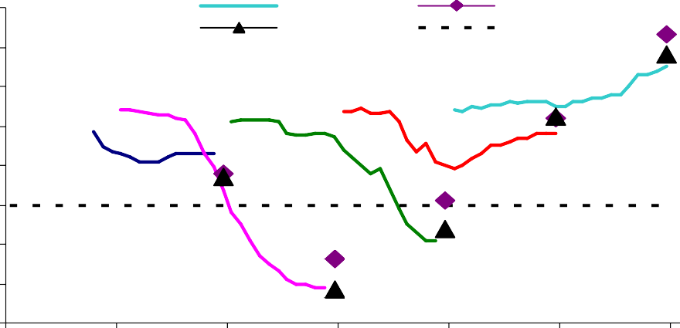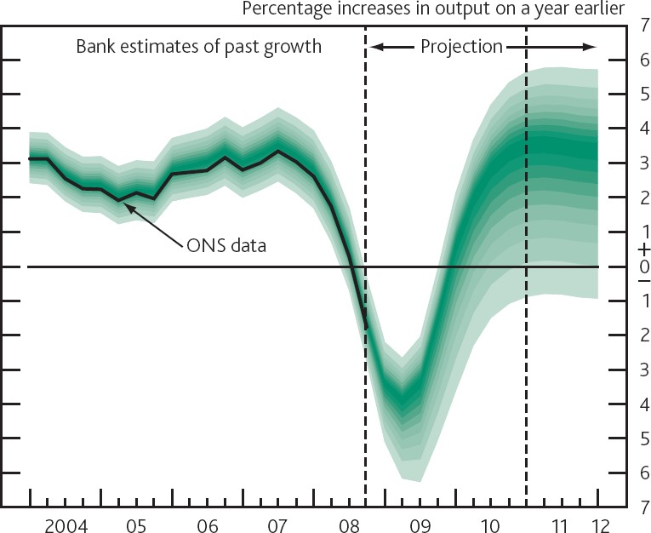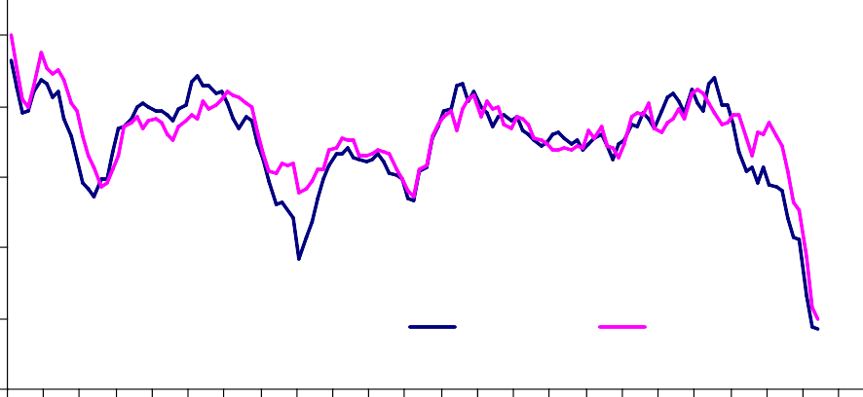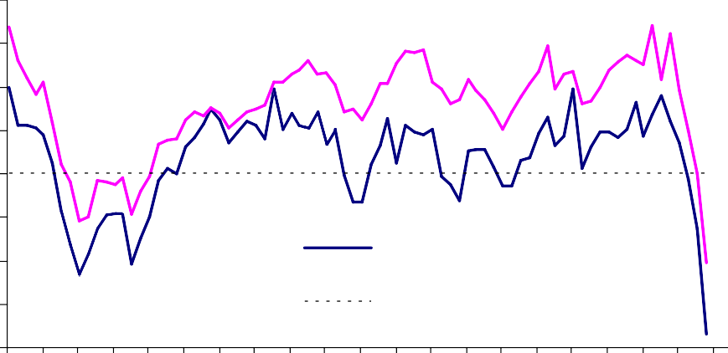

Mar-89 Mar-90 Mar-91 Mar-92 Mar-93 Mar-94 Mar-95 Mar-96 Mar-97 Mar-98 Mar-99 Mar-00 Mar-01 Mar-02 Mar-03 Mar-04 Mar-05 Mar-06 Mar-07 Mar-08

Mar-09

Source: BCC

# Chart 5: CIPS employment surveys

Index 60



**Manufacturing**

**Services**

55

50

45

40

35

30

Jul-91 Jul-92 Jul-93 Jul-94 Jul-95 Jul-96 Jul-97 Jul-98 Jul-99 Jul-00 Jul-01 Jul-02 Jul-03 Jul-04 Jul-05 Jul-06 Jul-07 Jul-08

Jul-09

# Chart 6: AEI and AWE measures of wage growth

Per cent 8



AEI

AWE

7

6

5

4

3

2

1

0

Jan-00

Jan-01

Jan-02

Jan-03

Jan-04

Jan-05

Jan-06

Jan-07

Jan-08

Jan-09

Source: CIPS

# Chart 7: Expected pay settlements in 2008 and 2009

Percentage of resp onses(a)

60

2008 survey

2009 survey

Source: ONS

# Chart 8: CPI inflation projection at market interest rates

50

40

30

20

10

Pay freeze 0 to 1% 1% to 2% 2% to 3% 3% to 4%

0

>4%

(a)Weighted by employment, excludes firms that were ‘uncertain’ about prospective settlements

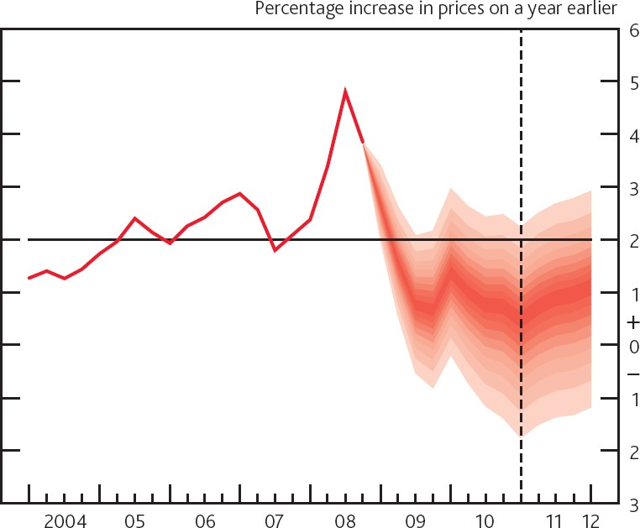

Source: BoE Agents' summary of business conditions February 2009

Source: BoE Inflation Report February 2009

# Chart 9: Employment decisions being made by firms

**Chart 10: UK Fear of Unemployment**

Balance 100

80

60

40

20

0

-20

-40

Jan-88 Jan-89 Jan-90 Jan-91 Jan-92 Jan-93 Jan-94 Jan-95 Jan-96 Jan-97 Jan-98 Jan-99 Jan-00 Jan-01 Jan-02 Jan-03 Jan-04 Jan-05 Jan-06 Jan-07 Jan-08 Jan-09

Source: Bank of England Agents' summary of business conditions, Feb 2009

# Chart 11: Unemployment and GDP deviations

Unemployment Rate

Deviation of Output from Trend

14



12

10

8

6

4

2

0

-2

-4

1971 1976 1981 1986 1991 1996 2001 2006

Source: ONS and Bank calculations

Source: GfK

# Chart 12: Unemployment Rates

% %

16 8

**Total (rhs)**

**Youth (lhs)**

15 7

14 6

13 5

12 4

11 3

10 2

9 1

8 0

1999 2001 2003 2005 2007

Source: LFS

0 2 4 6 8 10 12 14 16 18 20 22 24

Source: ONS Key Population and Vital Statistics 2006

650

700

750

800

**Chart 13 : Population by age in 2006**

000's

850